**CPC Application Setup**

* **Required Software:**
* Spring Tools Suit 4: <https://spring.io/tools>
* JDK 1.8 OR Above: <https://www.oracle.com/in/java/technologies/downloads/>
* Lombok 4.1.22: <https://projectlombok.org/download>
* SQL Developer: <https://www.oracle.com/database/sqldeveloper/technologies/download/>
* Apache Tomcat-8.5.83: <https://maven.apache.org/download.cgi>
* **Lombok Setup:**
* Go to the Downloaded Location of your Lombok And open It through CMD
* Run these Command: java -jar [version of your Lombok Jar]

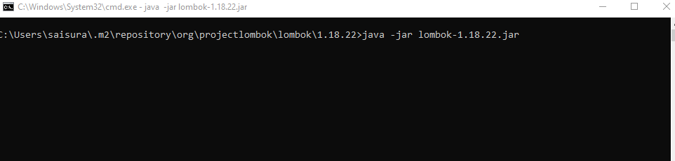

* This Window gets Displayed After Running the Above Command and do specify the location of your IDE.

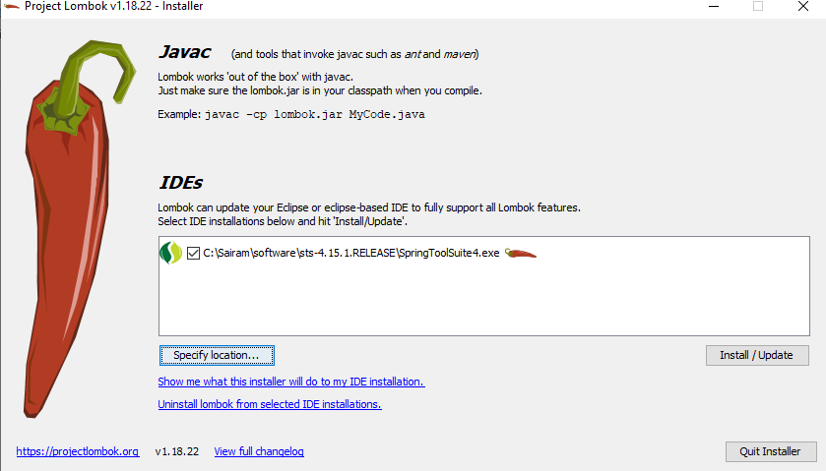

* Click on Install/Update. Then it creates Lombok JAR in your IDE location
* **Bit Bucket Url:** <https://gitscm.cisco.com/scm/it-cits-itbusinesstransformation-ciscopowercalculator/cpc-tomcat7.git>
* After Login through the Bit Bucket URL do pull the required branch from your IDE.
* **Files Adding to the Pulled Application**
* Add the templates folder in the specified Location: src/main/webapp/WEB-INF

* Document that needs to be add is mentioned Below:



* **Create a Server and Add these**
* Add these in context.xml in the servers application:

<Resource auth=*"Container"* driverClassName=*"oracle.jdbc.OracleDriver"* maxActive=*"40"* maxIdle=*"20"* maxWait=*"-1"* name=*"jdbc/cpc"* password=*"********"* removeAbandoned=*"true"* testWhileIdle=*"true"* timeBetweenEvictionRunsMillis=*"30000"* type=*"javax.sql.DataSource"* url=*"jdbc:oracle:thin:@ldap://ldap-ldprd.cisco.com:5000/cn=OracleContext,dc=cisco,dc=com/MKWBSTG"* username=*"********"*/>

* Add thes in tomcat-user.xml in the servers application:

<role rolename=*"tomcat"*/>

<role rolename=*"role1"*/>

<user password= *your username* roles=*"tomcat,role1"* username= *your username*/>

* **Setting Up the SQL Developer:**
* Open the SQL Developer and click on the plus icon in the connections section.
* Graphical user interface, text, application, email

  Description automatically generated
* This window get pops and add the below shown in that and click on save and then connect.
* 